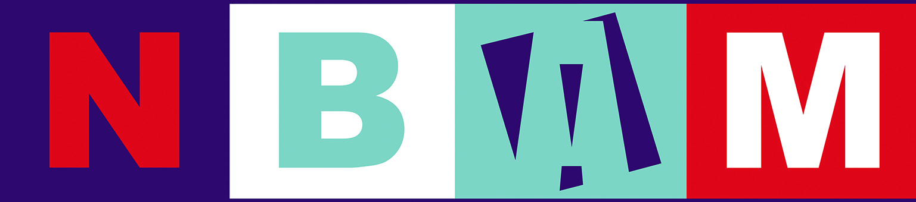

New Bedford Art Museum/Artworks!
TAIP: TEEN ARTIST INTERNSHIP PROGRAM 2018
STUDENT APPLICATION

Contact Information Todays Date: ______________

Student Name: ______________________________________________________________________________
Last First Middle
Home Address:
Street Name Apt./P.O. Box #
__________________________________________________________ Zip Code: ______________
City State

Home Phone # ___________________________ Cell Phone # ______________________________

Email Address: ______________________________________________________________________

High School Currently Attending: ____________________________________________ Grade: _______

Will transportation to and from your internship be a problem? yes no
If yes, please describe: _________________________________________________
Do you have any other responsibilities or obligations that could interfere with your internship? yes no

If yes, please describe days and times.
____________________________________________________________________________________
____________________________________________________________________________________

The TAIP program requires a minimum of 4 hours per week for nine weeks. Candidates must commit
to the time required to ensure successful outcomes.
How did you hear about NBAM/ArtWorks! Teen Artist Internship Program?

___________________________________________________________________________________
Tell Us About You

What types of Art are you interested in? ___________________________________________________

If you could choose your favorite medium, what would it be? ___________________________________

If you had to learn a new medium, what would you choose? ____________________________________

Who is your favorite artist? ______________________________________________________________

Essay: Answer the question: What inspires you to make artwork? (Minimum 100 Words)
Enclose separate sheet.

Application Deadline: October 31, 2017. Notification of Acceptance: November 30, 2017
Including: Student Application, Essays, and Sealed Teacher Recommendation Forms
Mail to: NBAM/ArtWorks! Attn: TAIP, 608 Pleasant St., New Bedford, MA 02740
Or Email all documents to dsmook@newbedfordart.org

